课后作业3
- 以下哪一项不是海森堡矩阵力学的出发点？
- 不对易关系；
- 量子化假定；
- 谐振子模型；
- 乘法交换律。√

- 以下哪些科学家参与了矩阵力学的建立？（多选）
- 海森堡；√
- 玻恩；√
- 约当；√
- 波尔。

- <即教材*问题1.5> 70分
Consider the wave function
$Ψ\left(x,t\right)=Ae^{-λ\left|x\right|}e^{-iωt}$
where $A$, λ, and $ω$ are positive real constants.
- Normalize $Ψ$.

$$\int{{\left|Ψ\left(x,t\right)\right|}^{2}dx}=\int{{\left|Ae^{-λ\left|x\right|}e^{-iωt}\right|}^{2}dx}={\left|A\right|}^{2}\int_{-∞}^{∞}{e^{-2λ\left|x\right|}dx}=2{\left|A\right|}^{2}\int_{0}^{∞}{e^{-2λx}dx}=\frac{{\left|A\right|}^{2}}{λ}=1$$
$$∴A=\sqrt{λ}$$
给出正确推导和答案给15分，只给出答案给5分

- Determine the expectation values of $x$ and $x^{2}$.

$$〈x〉=\int_{-∞}^{+∞}{x{\left|Ψ\left(x,t\right)\right|}^{2}dx}=\int_{-∞}^{∞}{x{\left|Ae^{-λ\left|x\right|}\right|}^{2}dx}={\left|A\right|}^{2}\int_{-∞}^{∞}{xe^{-2λ\left|x\right|}dx}=λ\int_{-∞}^{∞}{xe^{-2λ\left|x\right|}dx}$$
⸪ $xe^{-2λ\left|x\right|}$是奇函数 ⸫$〈x〉=0$
给出正确推导和答案给10分，只给出推导或者答案给5分

$$〈x^{2}〉=\int_{-∞}^{+∞}{x^{2}{\left|Ψ\left(x,t\right)\right|}^{2}dx}={\left|A\right|}^{2}\int_{-∞}^{∞}{x^{2}e^{-2λ\left|x\right|}dx}=2λ\int_{0}^{∞}{x^{2}e^{-2λx}dx}=-\int_{0}^{∞}{x^{2}de^{-2λx}}=-{\left.x^{2}e^{-2λx}\right|}_{0}^{∞}+\int_{0}^{∞}{e^{-2λx}dx^{2}}=\int_{0}^{∞}{2xe^{-2λx}dx}=-\frac{1}{λ}\int_{0}^{∞}{xde^{-2λx}}=-\frac{1}{λ}{\left.xe^{-2λx}\right|}_{0}^{∞}+\frac{1}{λ}\int_{0}^{∞}{e^{-2λx}dx}=-\frac{1}{2λ^{2}}\int_{0}^{∞}{de^{-2λx}}=\frac{1}{2λ^{2}}$$
给出正确推导和答案给10分，只给出推导或者答案给5分

- Find the standard deviation of $x$. Sketch the graph of ${\left|Ψ\right|}^{2}$, as a function of $x$, and mark the points $\left(〈x〉-σ\right)$ and $\left(〈x〉+σ\right)$, to illustrate the sense in which $σ$ represents the “spread” in $x$.

$$σ=\sqrt{〈x^{2}〉-{〈x〉}^{2}}=\frac{1}{\sqrt{2}λ}$$
给出正确答案给10分
${\left|Ψ\right|}^{2}$的图像如下图所示：
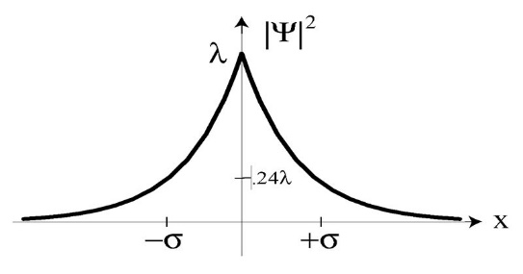
给出正确曲线和$\left(〈x〉±σ\right)$位置给10分，只给出一项给5分

- What is the probability that the particle would be found outside this range?
$$P=2\int_{σ}^{∞}{{\left|Ψ\left(x,t\right)\right|}^{2}dx}=2λ\int_{σ}^{∞}{e^{-2λx}dx}=-\int_{σ}^{∞}{de^{-2λx}}=e^{-2λσ}=e^{-\sqrt{2}}=0.2431$$

给出正确推导和答案（$e^{-\sqrt{2}}$或者$0.2431$）给15分，只给出答案给5分

- 30分
A photon propagates in the $z$ direction and passes a linear optical polarizer which is oriented in the $x$ direction (see figure below). The state in Figure (a) is $\left.\left|ψ_{x}\right.\right\rangle$ while the state in Figure (b) is $\left.\left|ψ_{y}\right.\right\rangle$.
- Write done the formula of $\left.\left|ψ_{c}\right.\right\rangle$, assuming the light beam is linearly polarized with an angle of α to the $x$ axis.
$$\left.\left|ψ_{c}\right.\right\rangle =\cos{α}\left.\left|ψ_{x}\right.\right\rangle +\sin{α}\left.\left|ψ_{y}\right.\right\rangle$$
给出正确答案给10分
- How much is the probability that a single photon could pass the polarizer in (c)?
$$P={\left|\cos{α}\right|}^{2}$$
给出正确答案给10分

- How does the system maintain the normalization condition?
$${\left|\cos{α}\right|}^{2}+{\left|\sin{α}\right|}^{2}=1$$
给出正确答案给10分

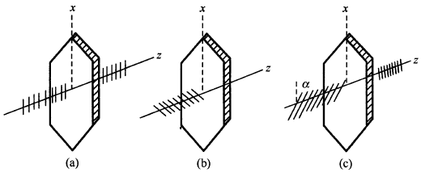

* David J. Griffiths, and Darrell F. Schroeter, Introduction to Quantum Mechanics (3rd Edition), Cambridge University Press (2018).

